

* Ambulance Services
* Biomedical Engineering
* Critical Care Services
* Health Checkups
* Intensive Care Unit
* Laboratory
* Mediclaim / Health Insurance
* Pharmacy
* Room Types

Ambulance Services

The Ambulance Service is an integral part of Emergency Medicine Department. We have a fleet of ambulances with the necessary facilities, like monitors, defibrillators, ventilators and continuous oxygen supply. The fleet is supported by paramedics skilled in transportation of seriously ill patients and victims of road traffic accident. They are trained in Advanced Cardiac Life Support and Advanced Trauma Life Support

Helpline No.: 79049 99929

Department Of Biomedical Engineering

A skilled team biomedical engineer’s service is available at the hospital. The team provides efficient support in maintaining the various equipment in the hospital in a good working condition. The department functions round the clock to render emergency service support on equipment breakdown or equipment.

The department ensures the quality functioning of all categories of equipment in the multi specialties of the hospital. The biomedical engineering department plays an important role in aiding smooth and complete patient care.

Critical Care Medicine-ICU

The hospital has the following intensive care units:

The critical care units are equipped with the state of the art diagnostic, monitoring and therapeutic devices. Adopting international guidelines and protocols in the organization and patient care, all the critical care units are staffed with an adequate and well qualified critical care team. The units have round the clock access to Microbiologists, Radiology & laboratory services, Physiotherapy and Dietary services, thus making them comprehensive and unique. Delivering efficient care to the critically ill patients, the units rise up to international standards. A special mention must be made about the medical intensive care units, which includes the intermediate care units also. Together, the complex is a 15 bedded multi speciality critical care area. It is the largest in this region and run by a team of qualified and experienced intensivists.

* Medical Intensive Care unit
* Intensive Cardiac Care Unit
* Intensive Respiratory Care Unit
* Intermediate Medical Care Unit
* Surgical Intensive Care Unit
* Trauma Ward

The intensive care units are equipped with ventilators, temporary pace making facilities, defibrillators and high quality monitoring equipment. Facilities for dialysing the patients have been provided. All intensive care units are managed by fully trained and experienced intensivists and senior physicians, ably supported by anaesthetists, cardiologists, pulmonologists, neurologists, nephrologists, gastroenterologists. With a well-structured team work, the best care is always ensured to the patients. Emergencies ranging from acute myocardial infarction, stroke and poisoning to any kind of situation requiring emergency medical management are treated with a very good success rate.

Health Plan

CUDSH Health Plan offers various health check-up programs. Through these comprehensive programs, diseases like diabetes, hypertension, anemia, cardiac disorders, kidney disorders, neurological diseases, liver problems, respiratory disorders, occupation-related health problems, and even cancers can be identified at an early treatable stage. These health check-up programs require no hospital stay.

Instructions

* Please come to the department at 7 am with empty stomach. You will be required to give fasting blood samples. Breakfast will be provided at the department. All the formalities, including registration and billing, are done at the department.
* No Hospital Stay.
* For enquires or booking contact : +91 79049 99929

Personal Care

* You will be seen by specialists in the various departments, and will be seen by a senior physician for a complete and final evaluation.
* Dieticians will give you counseling regarding your diet.
* You will be guided by volunteers.
* Priority will be given to you at the diagnostic service areas.
* The department has a clean and pleasant ambience, and all the facilities to take care of your needs

List of Health Checkup Programs

* Comprehensive Health Checkup
* Executive Health Checkup
* Master Health Checkup
* Senior Citizen’s Health Checkup for Women
* Senior Citizen’s Health Checkup for Men
* Comprehensive Diabetic Checkup
* Pre-employment Checkup
* Sweet Check / Diabetic Check

Comprehensive Health Check Up

Particulars

* Complete blood count
* Fasting blood sugar
* Post prandial blood sugar
* Glycosylated Hb(HbA1c)
* PSA (for men only)
* Blood urea
* Thyroid Profile
* Serum bilirubin
* Serum creatinine
* Lipid profile
* Serum uric acid
* Blood grouping & typing
* Urine complete analysis
* Stools examination
* Mammogram(Optional for women only)
* Serum Uric Acid
* Microalbuminuria
* Serum protein
* Pap smear ( for women only)
* Chest X-Ray
* ECG
* Ultrasound Abdomen
* ECHO / TMT
* ENT Checkup
* Dental checkup
* OG / Surgery consultation
* General physician consultation
* Diet Counseling

Excutive Health Check Up

Particulars

* Complete blood count
* Fasting blood sugar
* Post prandial blood sugar
* Glycosylated Hb (HbA1c)
* Blood urea
* Serum creatinine
* Lipid profile
* Serum uric acid
* Blood grouping & typing
* Urine complete analysis
* Stools examination
* Pap smear (for women only)
* Chest X-Ray
* ECG
* Ultrasound Abdomen
* ECHO / TMT
* Eye checkup
* ENT Checkup
* Dental checkup
* OG / Surgery consultation
* General physician consultation
* Diet counseling

Master Health Checkup

Particulars

* Complete blood count
* Fasting blood sugar
* Post prandial blood sugar
* Glycosylated Hb(HbA1c)
* Lipid profile
* Serum creatinine
* Serum bilirubin
* Serum proteins
* Serum uric acid
* Blood grouping & typing
* Urine complete analysis
* Stools examination
* Pap smear ( for women only)
* Chest X-Ray
* ECG
* Ultrasound Abdomen
* Eye checkup (with Refraction)
* ENT checkup
* Dental checkup
* OG / Surgery consultation
* General Physician consultation
* Diet counseling

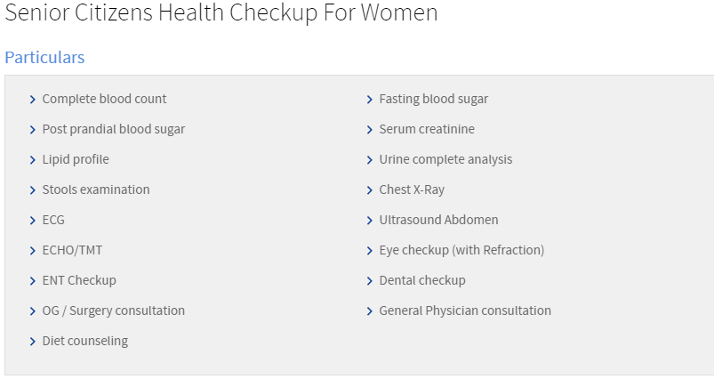

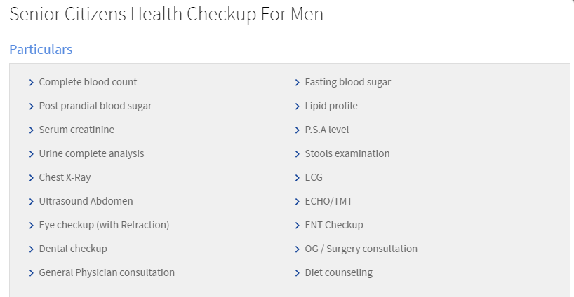

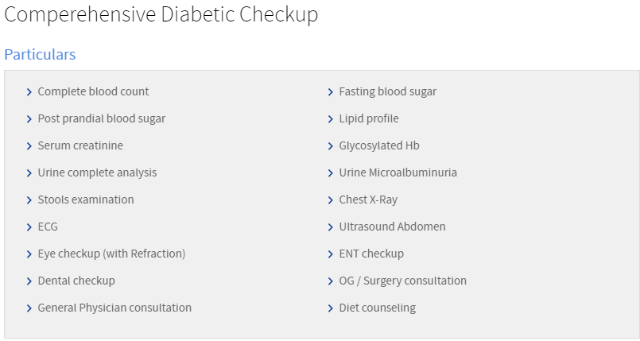

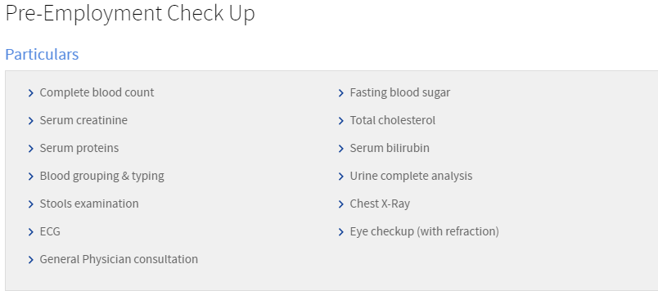

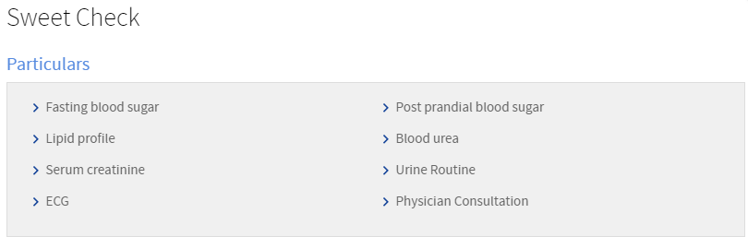

Intensive Care Unit

The Intensive Care Unit at CUDSH Hospital is a 9 bedded specialized section that provides comprehensive and continuous care for persons who are critically ill. Qualified healthcare professionals or Intensivists who work in the ICU provide round-the-clock intensive monitoring and treatment of critically ill patients seven days a week.

At CUDSH, ICU Care constitutes a multidisciplinary team that including intensivists (clinicians who specialize in critical illness care); pharmacists and nurses; respiratory care therapists; and other medical consultants from specialties including surgery, medicine, gastroenterology, neurology, nephrology and endocrinology.

While the intensivist provides treatment management, diagnosis, interventions, and individualized care for each patient recovering from severe illness, the qualified dieticians and the nutritionists take care of the dietary services so as to keep the patient from any nutritional deficiencies. The ICU also has qualified physiotherapists who are available 24 hours for the benefit of the patients.

Utmost care is given to patients with diseases and disorders that are regarded as medical justification for admission to an ICU. These categories include disorders of the cardiac, renal, nervous, pulmonary, and endocrine (hormonal) systems.

The mechanical ventilator assists the patient’s breathing, depending on the needs of the patient. For patients who need the greatest amount of assistance, the ventilator fully controls the volume and duration of breath throughout the respiration cycle.

The patients have access to 24 hour dialysis in ICU itself and each bed has high-end multipara monitors to monitor patients. Patients are given 24-hour assessments by the intensivist. Preparatory orders for the ICU generally vary from patient to patient since treatment is individualized. Well-coordinated care at the critical care unit includes prompt consultation with other specialists soon after the patient is admitted to the ICU. The patient is connected to monitors that record his/ her vital signs (pulse, blood pressure, and breathing rate).

The central monitoring system also enables monitoring of all patients from one place. The Unit has dedicated USG machine and defibrillators. Nursing care also plays an important role in the intensive care unit. The nurse’s role usually includes clinical assessment, diagnosis, and an individualized plan of expected treatment outcomes for each patient. The ICU has qualified staff nurses to take care the patient round the clock.

Strict infection control protocols practiced at the ICU ensures cent percent sterility. Facilities for isolating critically ill patient with contagious diseases are also available here.

Laboratory

The CUDSH is supported by very well-equipped, modern labs for Clinical Pathology, Haematology, Biochemistry and Microbiology. Our lab is equipped with latest fully computerized state of the art equipments which ensure accuracy and dependability of the investigations done.

Microbiology

The Department of Microbiology is well equipped to teach and diagnose most of the infectious diseases prevalent in the society. The department offers diagnostic services to the hospital regarding Serology. Basic Molecular biology equipment like Thermocyler, Gel documentation system, Refrigerated centrifuge etc., are available for research purposes.

Biochemistry

The biochemistry laboratory of the hospital is equipped with modern equipments/

The lab has a work force of about 6 qualified well trained technicians and technologist running the laboratory 24/7 all 365days.

Mediclaim / Health Insurance

* Medi Assist India Pvt Ltd
* Vidal Health TPA Services
* Star Health & Allied Insurance Company Ltd
* ICICI Lombard GIC Ltd
* Family Health Plan Ltd
* United Healthcare Parekh TPA Ltd
* Bajaj Allianz General Insurance Company Ltd,
* Vipul Med Corp TPA Pvt Ltd
* Apollo Munich Health Insurance Co Ltd
* Paramount Health Services TPA Pvt Ltd
* MD India Healthcare Services Private Ltd
* CIGNA TTK Health Insurance Company Ltd
* Dedicated Healthcare Services TPA India Pvt Ltd
* L&T Insurance Company LtdM
* Heritage TPA Pvt Ltd
* Religare Health Insurance Company Ltd
* Cholamandalam MS general Insurance Company Limited
* Medsave Healthcare TPA Ltd
* Max Bupha Health Insurance Company Ltd
* Reliance GIC Ltd
* E-Mediteck TPA Services Ltd

Cashless Claims Procedure:

A. Admission Procedures

To check the availability for cashless through ID Cards

The beneficiaries (patient) will be identified by the provider (hospital) on the basis of an ID card issued from TPA to all the beneficiaries.

The ID card shall have photograph and signature or thumb impression of the Patient.

Whenever there is a need for hospitalization the policyholder should bring their ID card and policy copy.

Insurance clerk will verify following details through ID card & policy copy

* TPA Name
* Corporate name
* Patients name and spelling
* Card validity period
* Age verification
* Photograph verification
* Pre-existing coverage
* Sum-insured

Our Insurance Coordinator will explain clearly about the terms & conditions for availing cashless facility to the patient/attendant.

B. Pre-Authorization

The terms & conditions for providing cashless facilities to the patient.

* When a doctor plans for admission, the insurance staff will verify the ID Card, Photo Id , Policy Copy and gets the concerned pre-authorization form filled up and signed with the seal of the doctor. The Patient / attender has to sign and enter the contact number in the pre-auth form. The same is sent to TPA / IC along with relevant investigations reports in case of planned admission. This can be done up to 7 days prior to expected date of admission.
* In case of emergency admission the pre-authorization form should be sent within 24 hours after admission. Any delay has to be communicated to TPA by insurance staff.
* The Pre authorization approval issued by the insurance company will have the following details like amount guaranteed, sub limits for room category, surgical fees etc., eligibility of beneficiary, validity Of the approval letter as per the benefit plan of the insured.
* The guarantee of payment is given only for the necessary treatment cost of the ailment covered and mentioned in the request for hospitalization. Any investigation or treatment carried out at the request of the patient apart from the authorization, those treatment charges will have to be borne by the patient.
* When the cost of treatment exceeds the authorized limit an interim bill along with justification letter from treating doctor is sent for further enhancement of approval amount. At the time of discharge final approval should be obtained by sending the final bill, break up bill, discharge summary, pharmacy break up bills, any other information as required by TPA. On receipt of final approval the following procedures has to be followed before discharge of the patient.

C. Discharge Procedures

The final approval will have the final eligible amount and remarks on exclusions like non-medical expenses, co-payment and other disallowances the cost of which has to be borne by the patient. Hence after collecting the same the patient can be discharged.

* If the enhancement amount is unauthorized, the balance amount should be collected from the patient.

If the total claim is denied the patient has to be treated as per hospital norms.

Pharmacy

The Pharmacy department at CUDSH is responsible for dispensing medications daily for the inpatient and outpatient population. It consists of pharmacists and support personnel, who work together to ensure that patients receive highest quality pharmaceutical care.

The CMC Pharmacy, situated near the entrance, functions round the clock, throughout the year and is also kept open during public holidays. The pharmacy store is situated at the basement. Bulk stocks of all the medicines and surgical items are stored in the pharmacy stores. Medicines are procured from companies that set standards in quality. These include standard companies with good credentials.

The dispensing at the pharmacy counters is done by the pharmacists after carefully checking the medicines individually with the prescription.

The medicine requirement of special ward patients is handled by a dedicated billing and dispensing counter. Online prescriptions received at this counter are handled by a team of pharmacists and support personnel. Bulk medicines and fragile items like some ampoules etc., are delivered manually by the support staff.

The pharmacy department also has a Drug Information and Counselling Centre for the out patients, where clinical pharmacists provide information about the prescribed medicine; inform patients about dosage and; adverse effects; drug food interactions and the importance of drug intake without missing a dose.

Emergency medicines and those that are of high risk are labelled and stored separately. Drugs that are look-alike and sound-alike are stored with appropriate labelling so that there is no mix-up.

Medicines are provided for a number of free camps that is organized by the hospital on a monthly basis. The department maintains a pink coloured prescription sheet that can be easily identified, for the emergency and ICU cases so that they are given top priority during dispensing of drugs.

## Room Types

### 1. Suite

Well-furnished patient rooms with attendant cot with TV (cable connection), dedicated nurse station, Diet Service, Medicine tray, nurse calling facility, Patient wardrobe

### 2. Deluxe

Air-conditioned rooms and Non Air-conditioned rooms with tiled flooring, Visitors area and seating arrangement, TV facility with cable connection, attendant couch , Diet Service, Medicine tray, nurse call facility.

### 3. Special Room

Air-conditioned rooms and Non Air-conditioned rooms – well furnished & attached toilet, Attendant Couch and seating, Diet Service, nurse call facility, TV facility with cable connection.

### 4. General Ward

Six to eight patients in a cubicle and toilets in the wings of the ward, Fully-equipped Nursing Station, Attendant Couch, and diet Service.